ROWER’S/COXSWAIN’S NAME________________________________________________

As part of your student’s $700 registration fee, they will receive an official Briar Woods Crew Club ‘Spirit Pack’ containing one (1) of each of the following:

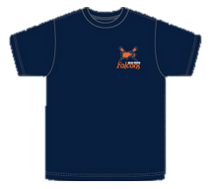
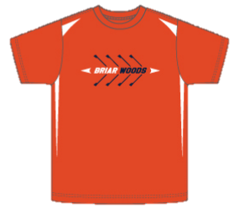
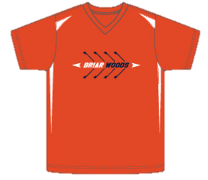
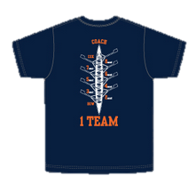
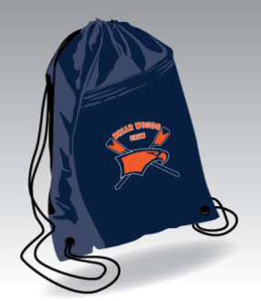
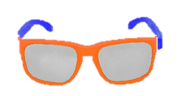
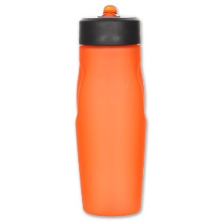
- Performance Polo Shirt
- Team Sponsors Tee *
- Performance Tee
- String Sack Pack
- Regular Tee
- Rower’s Cap
- Sunglasses
- Water Bottle

( * Team Sponsors Tee comes in ‘Men’ sizes only, so please select accordingly when ordering for women rowers)

Women’s Spirit Wear

Polo/Performance/Regular Tee

____Small

____Medium

____Large

____Extra Large

Team Sponsors Tee

____Small (Men’s size)

____Medium (Men’s size)

____Large (Men’s size)

____Extra Large (Men’s size)

Men’s Spirit Wear

Polo/Team Sponsor/Performance/Regular Tee

____Small

____Medium

____Large

____Extra Large

